Project Name |  | Confidentiality Level
DBMS |  | For Recipients’ Reference Only
Project ID | Version | Document Code
BP | 1.0 | BP

DBMS Project Start Report



Copyright © Ruankosoft Technologies (Shenzhen) Co., Ltd.
All Rights Reserved
Revision Record
Date | Revision Version | CR ID /Defect ID | Sec No. | Change Description | Author

Content
1. Project Proposal 5
2. Team building and Schedule 5
3. Risks Evaluating and Mitigating 5

Keywords: SDI MFC DBMS RDBMS Dialog C/S MVC Intergrity Database Table File Record
Abstract : This system is the first version of the database management system, including database creation, database table management, record addition and query, integrity constraint implementation, index creation and implementation, multi-user, concurrency processing, transaction processing, database backup and recovery, etc. This document describes the design of each functional module to help the software developers analyze and design the software better. At the same time, it helps the clients to give better suggestions.
List of abbreviations :
Abbreviations | Full spelling | Chinese explanation
SDI | Single Document Interface | 单文档界面
MFMFC | Microsoft Foundation Classese | 微软基础类库
DBMS | Database Management System | 数据库管理系统
RDBMS | Relational Database Management System | 关系型数据库管理系统
C/S | Client/Server | 客户/服务器模式
MVC | Model View Controller | 模型视图控制器

Project Proposal
1. Project ID:

2. Project Introduction:
Database Management System is large-scale software which can manipulate and manage the database. It is used establish, use and maintain the database, and called DBMS for short. It manages and controls the database in a unified manner to ensure the security and integrity of the database. The user accesses the databases through DBMS. It can make many applications and users establish, modify and query the database through different method at the same time or different moments. Most DBMS provided DDL (Data Definition Language) and DML (Data Manipulation Language) for users to define the schema structure and permission constraint of the database, and implement the data operation: add, delete, etc.

3. Project objective:
- Implement the project with DDL, DML, and DCL functions.
- The project mainly implement function like: Database Management, Table M management, Field Management and Data management etc.
- The interface of the project requirements beautiful, generous, clearness and better user experience.
4. System boundary:
Gaming peripherals are user’s inputting data. The data source is database file, database description file, table description file, record file, integrity description file and index description file.
The basic functions of DBMS are: Create database, Create table. description file, and Define table structure, Show table structure, Insert record and Selects record.

Database Management

Table Management

Field Management

Data Management

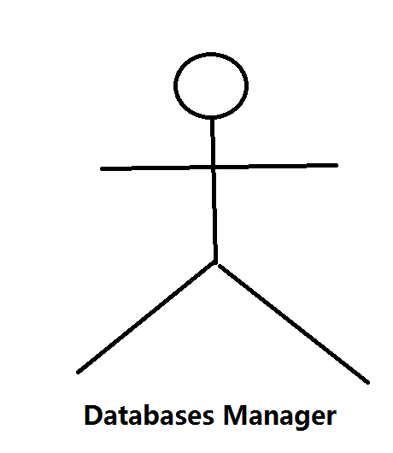

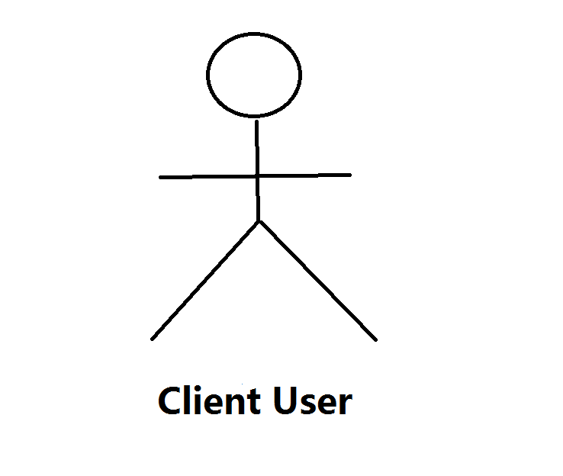
Index Management

Client Management

Transaction Management

Integrity Management

Database Maintenance

Security Management

5. Workload assessment:
Module | Sub-module | Workload（person/day） | Description
Create Project |  | 2 | Create a MFC SDI application.
Interface Design |  | 2 | Design main interface of database management system.
Data Structure |  | 2 | Design data structure to implement core functions of DBMS.
`Exception Handling |  | 2 | Design the exception handling method in the program
Create Database |  | 3 | Create table description information
Create Table Description file |  | 3 | Generate table description information
Defile Table Description file |  | 3 | Input the field information of table, save into the table definition file(.tdf), and display in the tree view and the list view.
Show Table Structure |  | 3 | This function includes read *.tdf file and display table structure.
Insert record |  | 3 | Insert a row of record in a specified table, and save to the record file(*trd)
Select record |  | 2 | Read the *.trd file of the specified table, and select all record, then display in the list view.
Workload in total（person/day） | 25 person/day
Remarks: Person/day means workload of the number of person & day

Team building and Schedule
1. Project Plan： 2017-04--26——2017—05-17

2. Chief Project Manager： Number： Name：

3. Project Manager： Number： Name：…

Project Team Member
Number：15301044 Name:马列
15301041 李文盛
15301045 聂文俊
5. Source of Staff：

Risks Evaluating and Mitigating
1. Technical Risks：
(1) Unfamiliar for Visual Studio 2010, use less of MFC Dialog, MFC SDI.
(2) Not familiar with DDL function, DML function and DCL function of the DBMS.
Resolution:
For self-learning and timely communication, mainly learn about the database knowledge.
2. Management Risks：
(1)Plan is not fully, so it is different to keep with the project schedule.
(2) The content of the project is too much.
Resolution：
- For project development, we should fully prepared and effective for time management.
- Seize the time to prepare the individual software quality.
3. Other Risks：
- Because of power outages and other reason, resulting in the loss of project data.
- Network status is poor, resulting in broken network.
Resolution：
- Back up the data frequently.
- Reasonable to arrange time to set aside space to solve risk.

